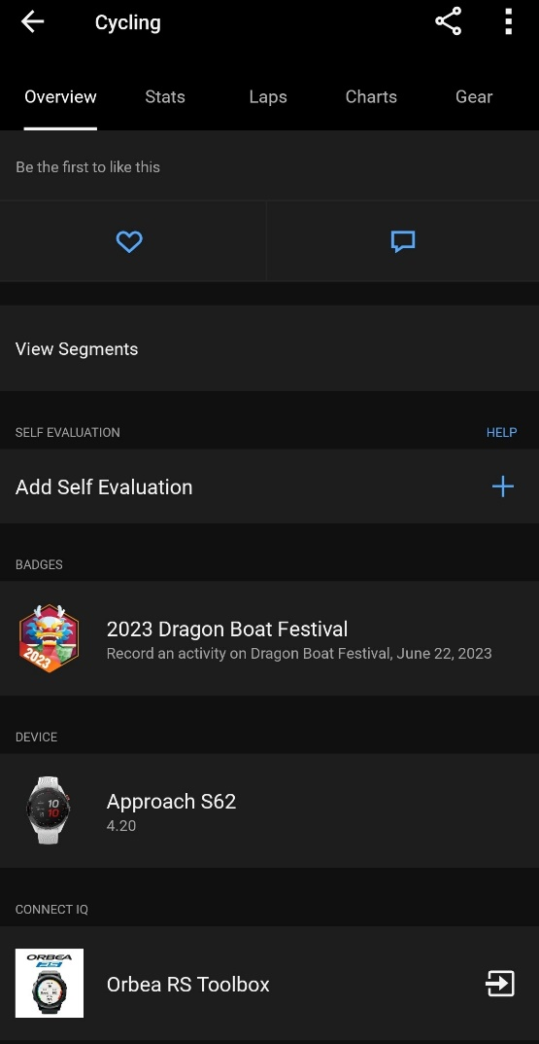

 4.20 Shows Orbea RS Toolbox

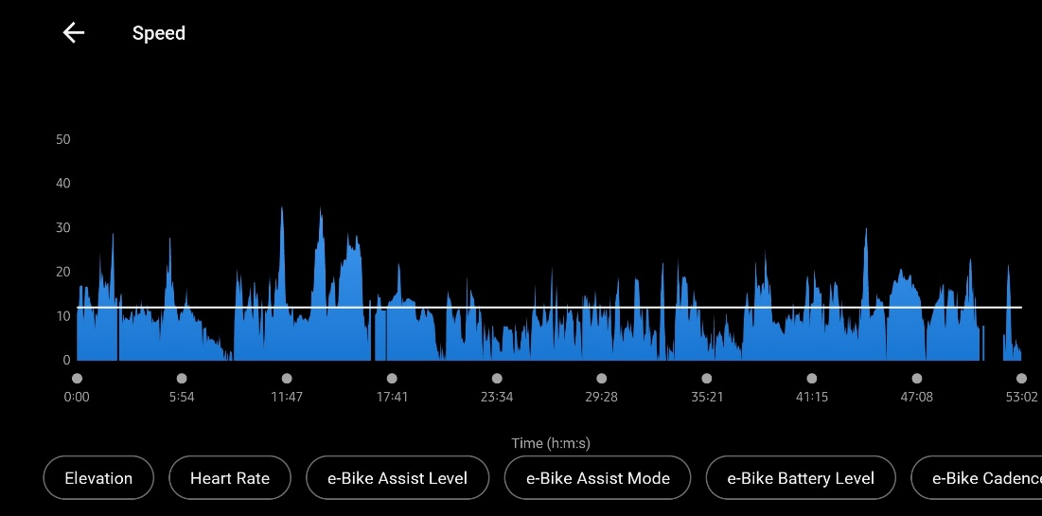

eBike data working fine.

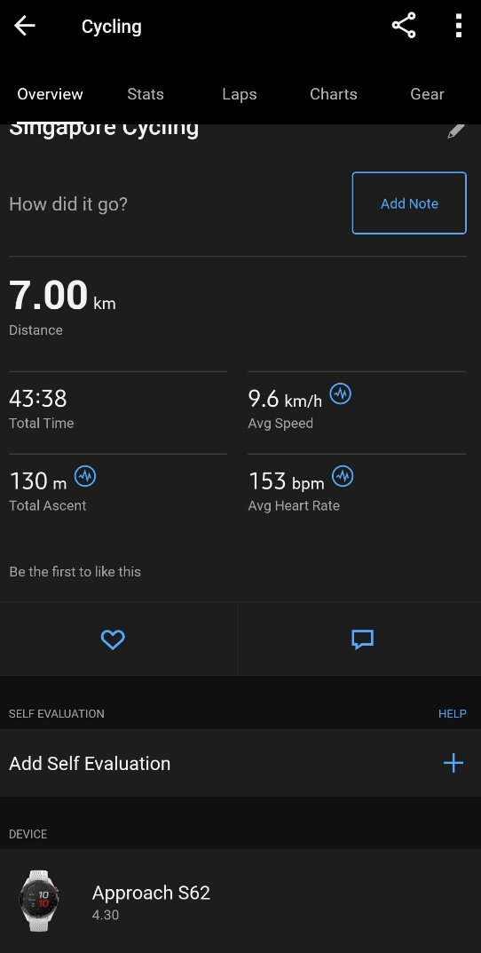

Ver 4.3 – Does not show Orbea RS Toolbox

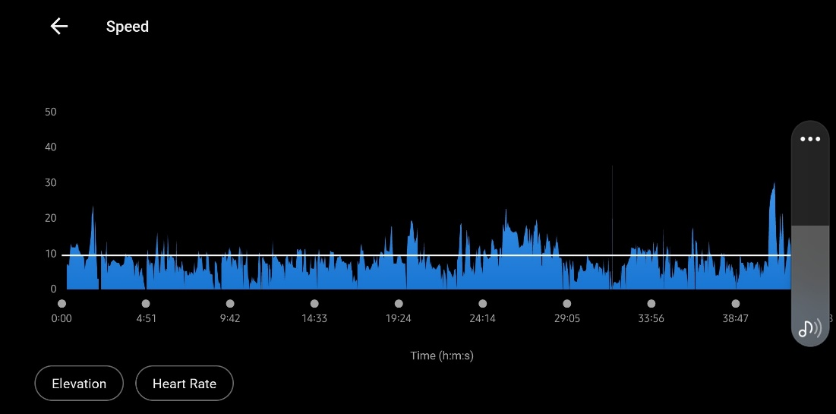

No eBike data

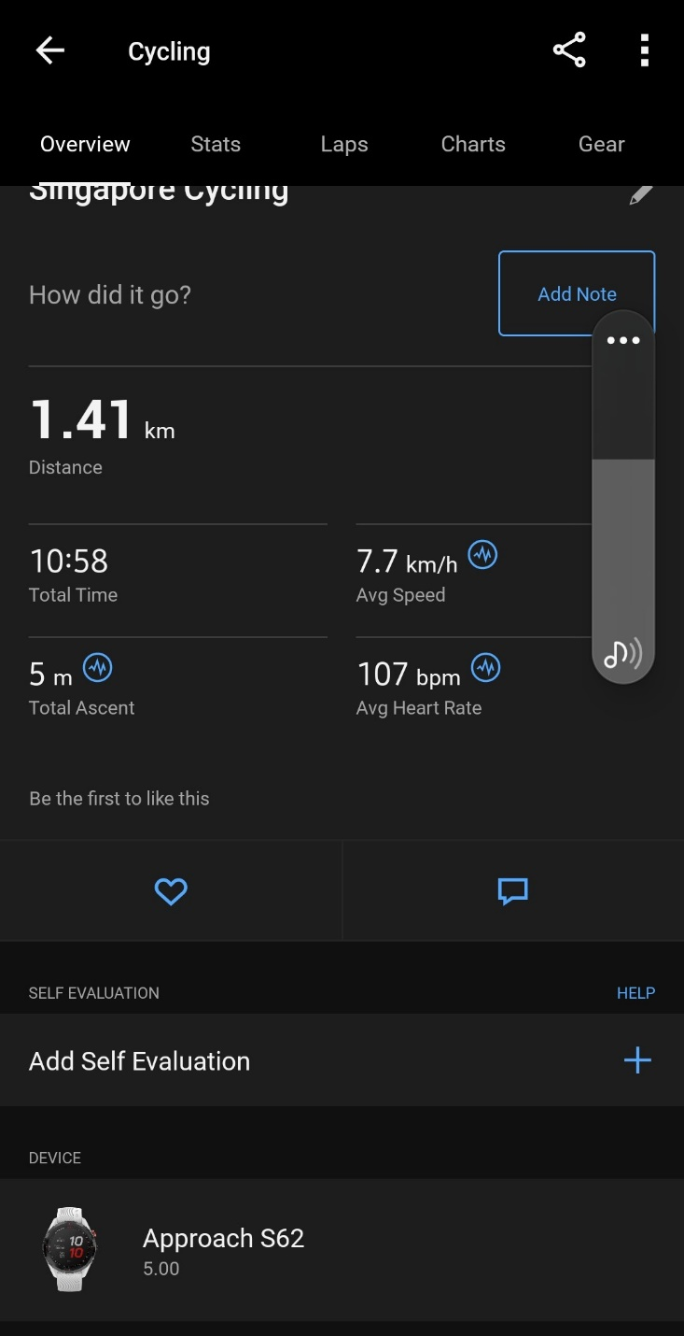

 Same all the way to ver 5.0

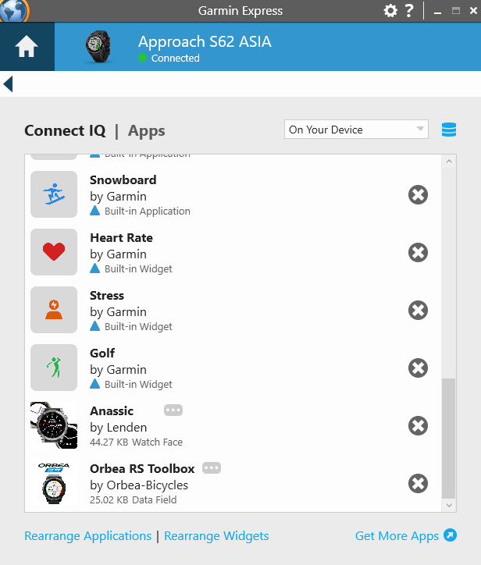

Orbea RS Toolbox is installed in the watch, updated to the latest version.