How to use M2 Designer in the simulator

Install Java Version 8 (if you do not have it) from: https://java.com/en/download/

Download the Garmin Connect IQ SDK (you do not need to install it, just unzip the folder):
- Create a directory that you will place everything in e.g. C:\Garmin
- You MUST make sure there are no spaces in the folder name or parent folder names. This is CRITICAL – I cannot highlight this enough!
- Download from https://developer.garmin.com/connect-iq/sdk/
- At the bottom of the page under "Direct Download".
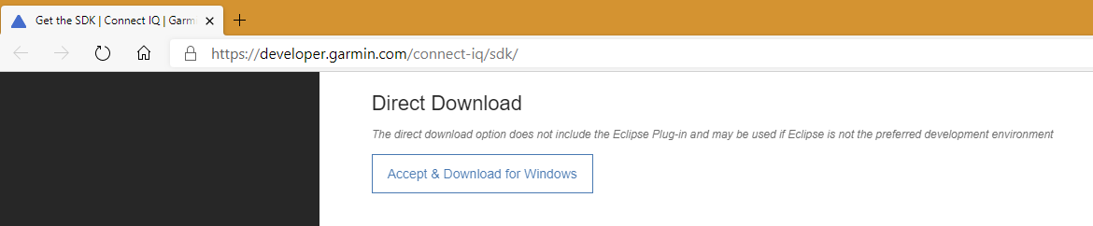
- Right click on the zip file, open the properties, and select “unblock” – which will allow the simulator to run after unzipping it.
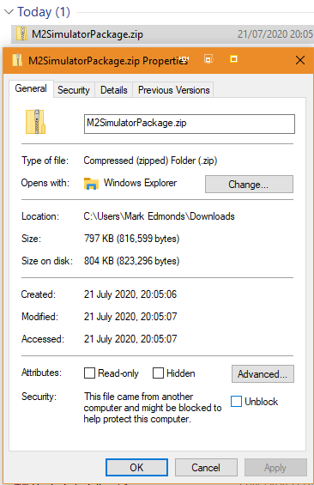
- Unzip the file to your chosen directory.
- Notice that inside the unzipped folder there is a "Bin" folder.

Download the M2 simulator package (you probably already have it as you are reading this):
- Download from https://1drv.ms/u/s!ArQ7iSnpSoQ2sscowpDhRWrTuZzAlA?e=NoUwcR
- Again, right click on the zip file, open the properties, and select “unblock” – which will allow the BAT files to run after unzipping it.
- Unzip the M2 simulator package and place the M2Sim folder directly inside the "Bin" folder (of the Garmin CIQ folder you created) - to make a Bin\M2Sim.
- Inside the M2Sim folder you will see:
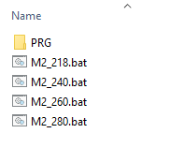
The PRG sub folder contains built versions of M2 Designer for different size watch screens.
The BAT files will run M2 designer on different watches - double click on one to run it.

Run M2 Designer in the simulator:
- Run the appropriate BAT file (ideally choose the one which has the same size display as your own watch):
- 218x218 - Fenix 5S Plus
- 240x240 - Fenix 5X Plus
- 260x260 - Fenix 6 Pro
- 280x280 - Fenix 6X Pro
- Create the design of your choice - by clicking on the watch buttons in the simulator.
How to get the "Profile Text" for your design:
- Select "File" > "Edit Persistent Storage" > "Edit Application.Storage data" (Or press CTRL + S).
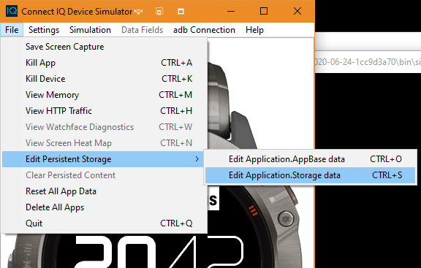
- Open "Dictio…(Hash)".
- Then open "Profile 1st half" and "Profile 2nd half".
- Click on the "String" underneath these, and the value is displayed to the right.
- Select the String in the box to the right in order to copy it - this is your normal "Profile Text" which you would normally get from the Garmin settings of the M2 Designer app.
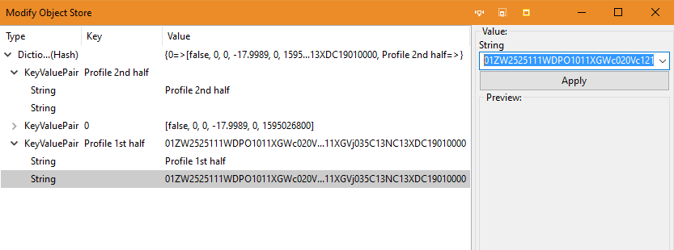

How to load a "Profile Text" that you have created or copied from elsewhere:
- Follow similar steps as described above for "Get the Profile Text".
- Select "File" > "Edit Persistent Storage" > "Edit Application.Storage data".
- Open the "Profile 1st half" and "Profile 2nd half" string values.
- Select the lower "Profile 1st half" string and paste your copy of the first half into the right side, then click Apply.
- Select the lower "Profile 2nd half" string and paste your copy of the second half into the right side, then click Apply.
- Click OK at the bottom right of the window to save the changes and load the profile.
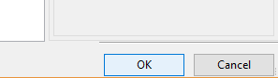
Notes:
- The initial design will start off completely blank in the simulator the first time you use it. You can load the default watchface via the menus:
  - Press down until you get to “load preset”.
  - Press select / right (to see “25. default”.
  - Press select / right again to load this default design.
  - Press back to go back again.
- You may see the graphics shifted by 1 pixel in the simulator (compared to on the watch) – this is just how the simulator works.
- Colors can look very different on your PC compared to your watch – it is often best to set these later on the watch itself using M2 Designer.
- System fonts may look different in the simulator – especially if the watch being used in the simulator is different from your own watch! If you edit the BAT file you can try changing the watch type that the simulator uses to match your own. (You may have to guess the name that the simulator uses …)

